User Manual

1)Registration

1. If the user does not have an account with the website, they’re prompted to make a new account

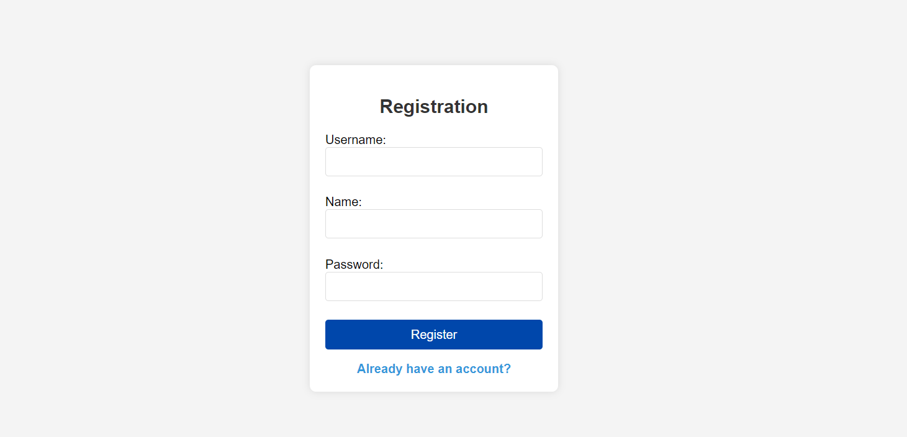

2) Login

1. Once the Registration has been completed, the user is prompted towards a login page so that they’re able to access their account

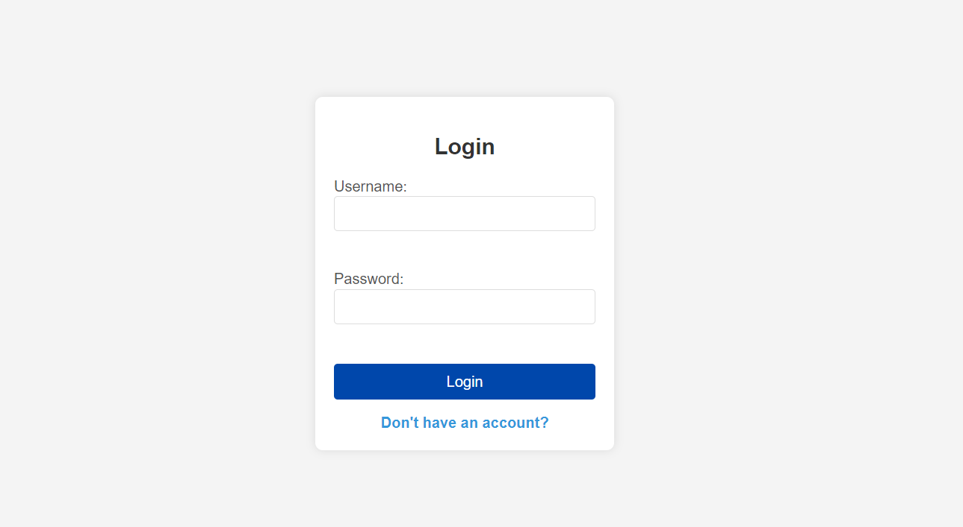

3) Home page

1. Once the user is logged in to their account on the **home** page they are able to see a list of the courses that they are **currently enrolled in** and they can see a list of the courses that **have been completed**

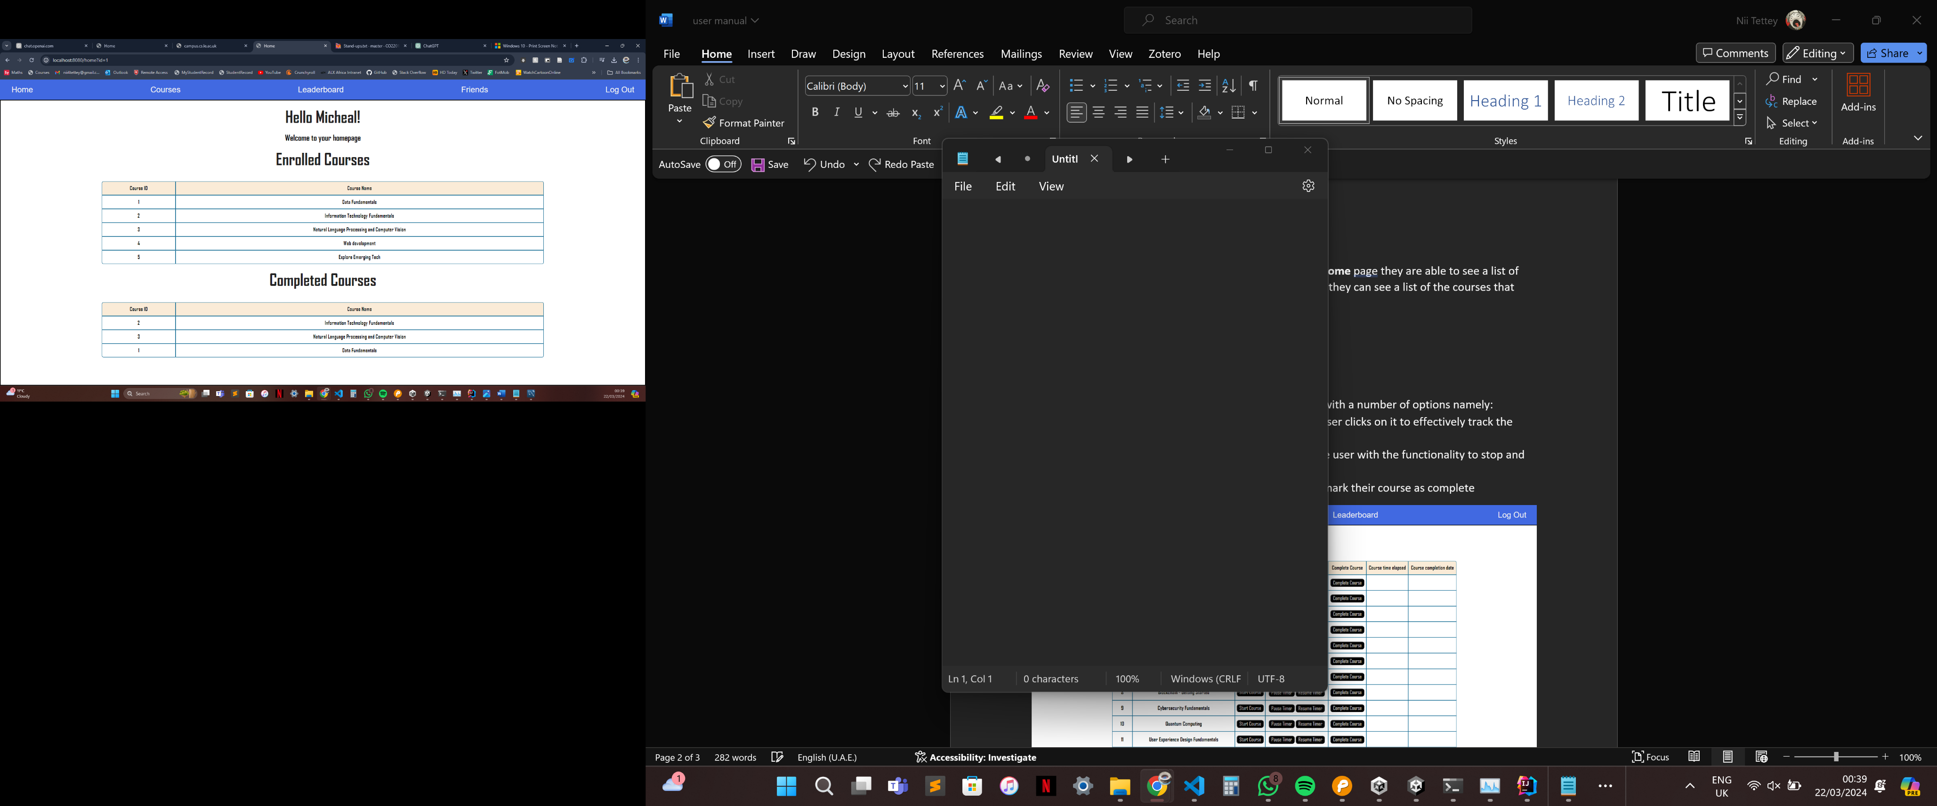

4) Viewing Courses

When you are on the courses page you can now select what courses, you would like to do from all the courses that are available all you have to do is click the check box and the course selected will be added to the list below.

Since your selected courses appear here the functionality is explained below regarding what all the buttons do. Additionally, the progress bar advances once the course is completed the progress bar will reach maximum when all your **selected** courses are complete.

* **Start Course –** this button starts a timer once the user clicks on it to effectively track the time taken for the user to complete the course.
* **Pause/Resume Course –** These buttons provide the user with the functionality to stop and resume the timer anytime they want.
* **A white rectangular object with black lines

  Description automatically generated with medium confidenceComplete Course –** This button allows the user to mark their course as complete.

You can also click the button view on this list which lists all the courses, and it will redirect you to the respective course on IBM skills build.

5) Leaderboard

* Upon clicking on the leaderboard the user is sent to the global leaderboard which shows a list of other users and their achievements, the top 10 users are granted a badge and the color of the badge varies according to the position of the user
* Golden – For the First place
* Gray – For the Second place
* Brown – For the Third place
* Purple – For the Fourth position
* Green – For the Fifth position
* Blue – For positions 6 to 10

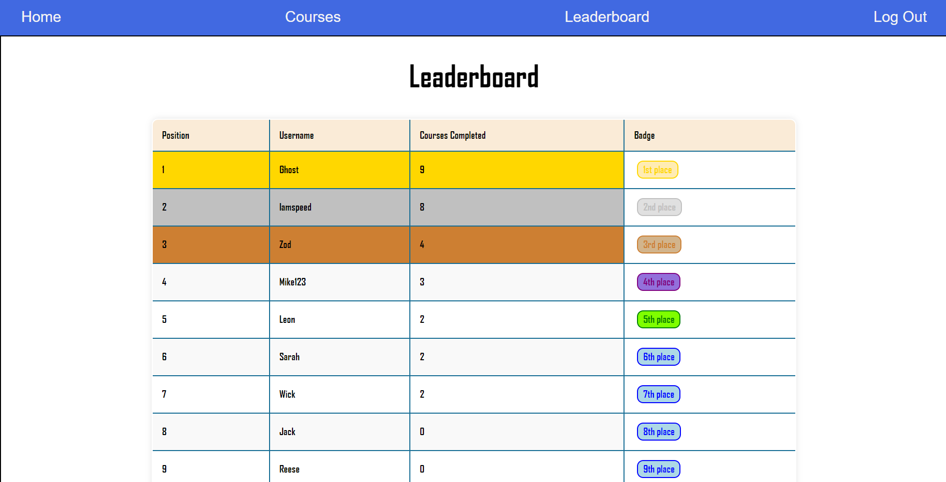

6) Logout

* The logout button in the top right allows the user to log out and once the logout button has been clicked the user is taken back to the login page

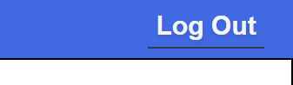

7) Friends System

* Shows you a list of your existing friends and allows you to search for users and send them friend request. 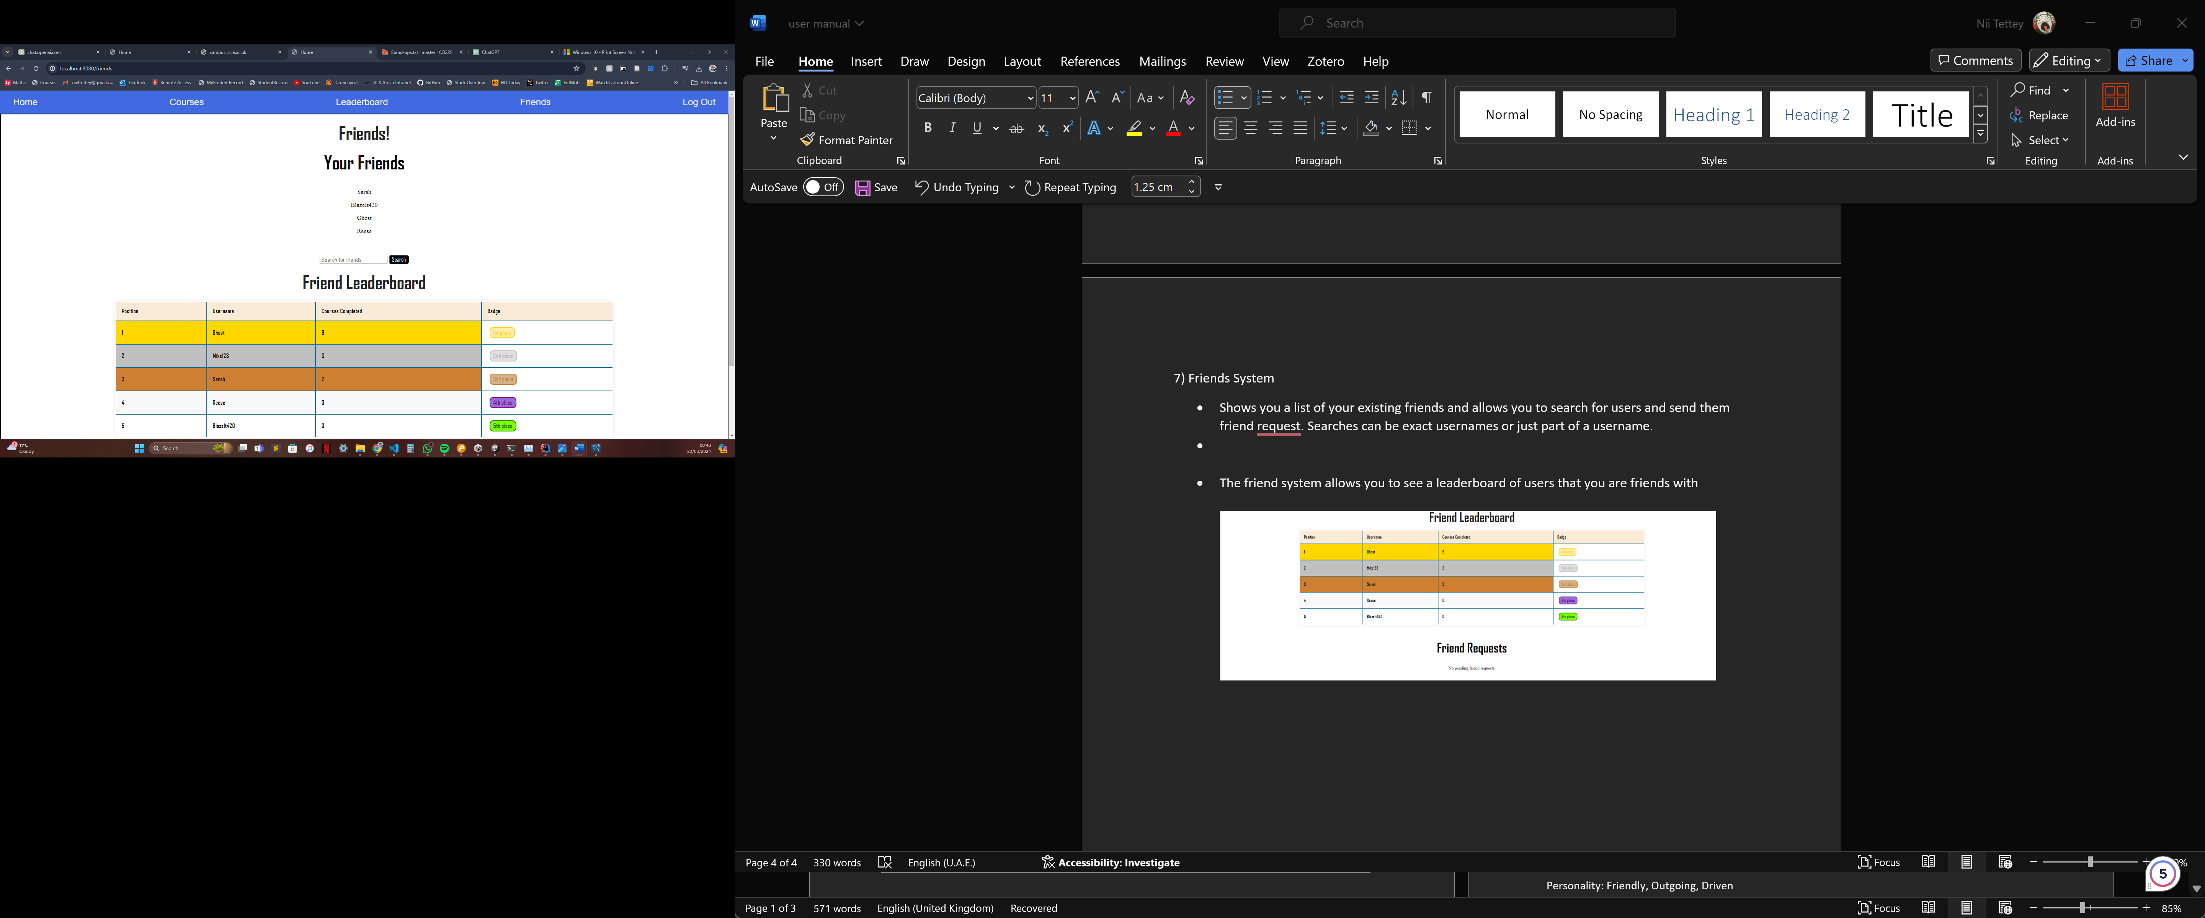
* Searches can be exact usernames or just part of a username. The search in the screenshot was “s”

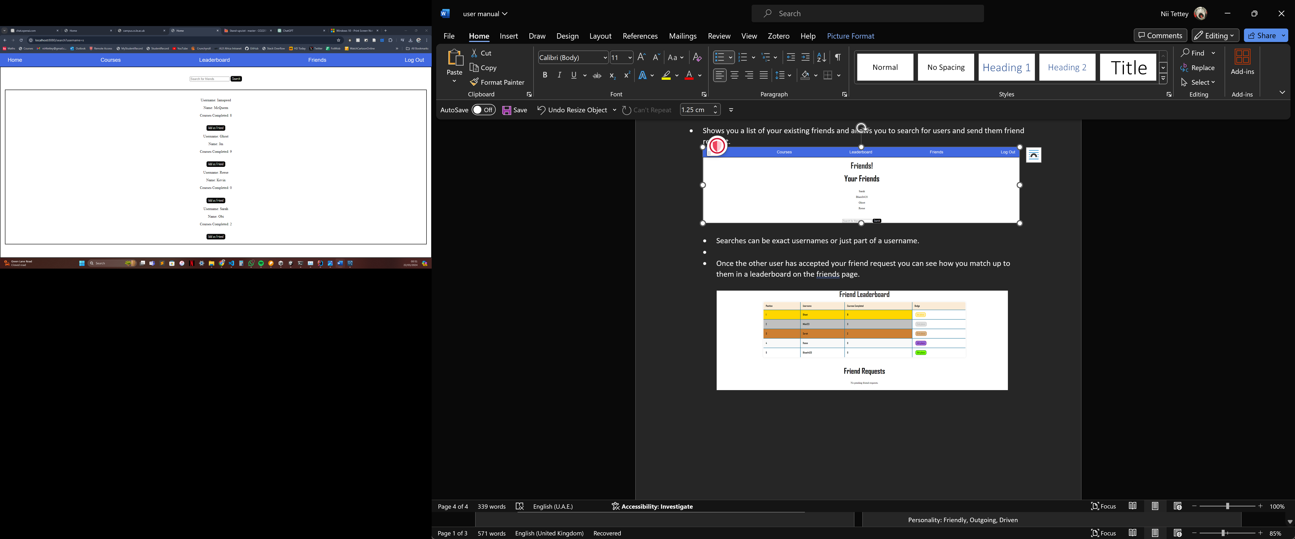

* Any friend requests will appear on the users’ friend page and can be accepted or rejected.

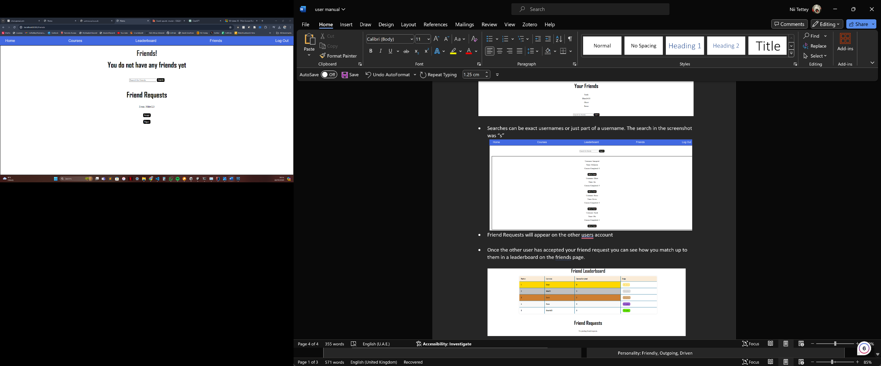

* Once the other user has accepted your friend request you can see how you match up to them in a leaderboard on the friends page and they will be added to your list of friends.

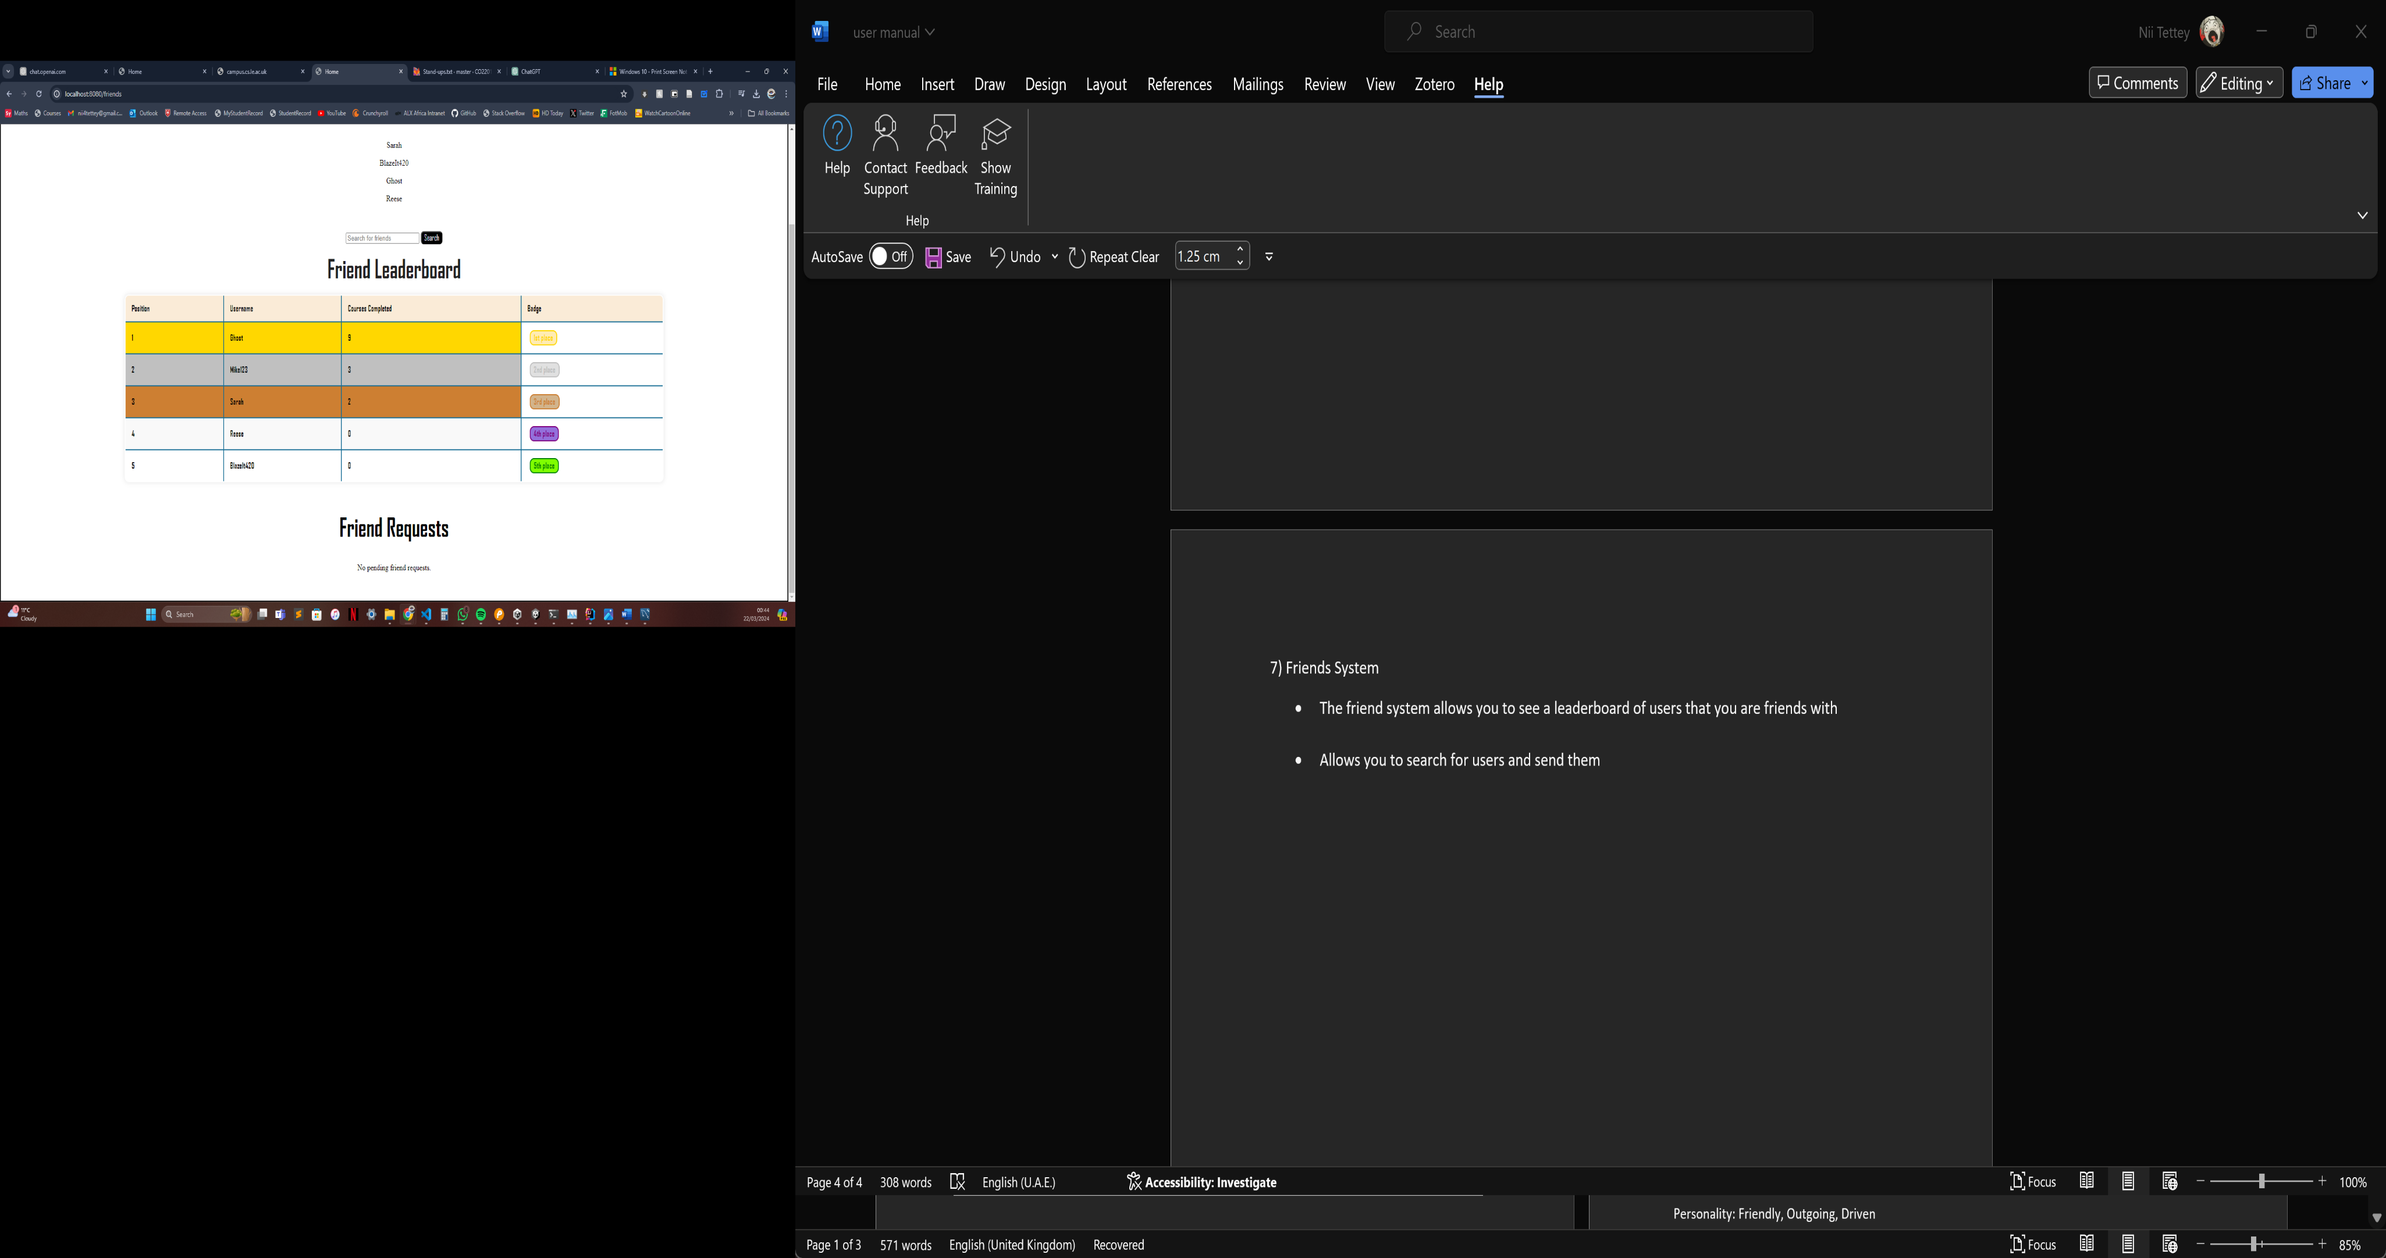

8) Admin Dashboard

There is a link from the main login page to the admin login page upon which the admin is prompted for administrator credentials.

Upon successful authentication the user will be directed to the main admin page as illustrated below consisting of a list of courses for the admin to view information of using the info button. The admin also has the ability to logout if desired using the logout button on the top right.

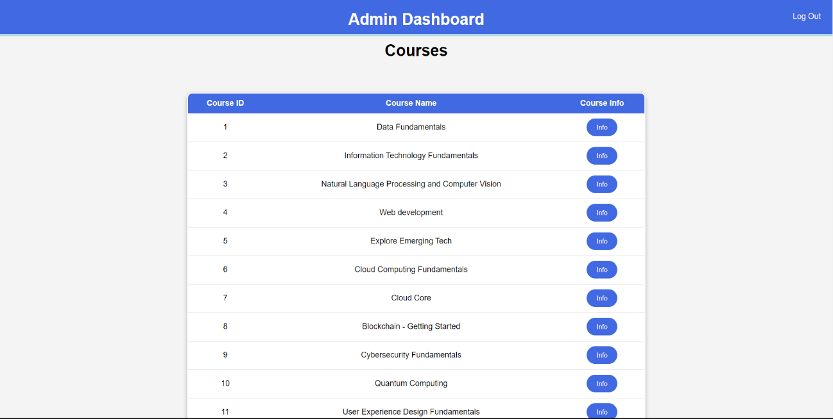

Clicking the info button will redirect the user to the course information page displaying dynamic charts with user enrolment and completion statuses of the course. The page also lists all the enrolled users for the specific course. The below image is an example a course information page for the data fundamentals course. The back to courses button will redirect the admin back to the main dashboard of all courses.

Each user in the course’s information page has a link to a user information page about that user. Clicking the username of a user in the table will then redirect the admin to the user information page for that specific user as shown below for the user Micheal.

The user information page lists all the courses the user is enrolled in as well as charts displaying how many courses the user has enrolled in as well as the user’s progress of courses. The page also lists all the courses that the user has enrolled in each of which has a link to the course information page for that course. The admin can view all the information as mentioned and can navigate back to the main dashboard to log out using the back button in the top left.